Concurrency Concepts

Riley Norgaard
CSU Global
26FB-CSC450-1
Professor Haseltine
October 11, 2026
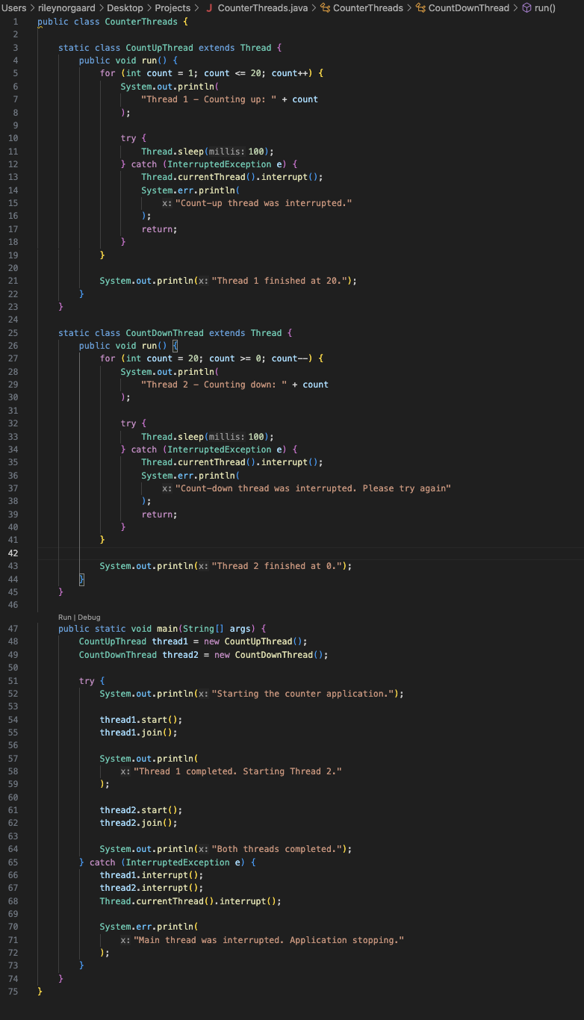
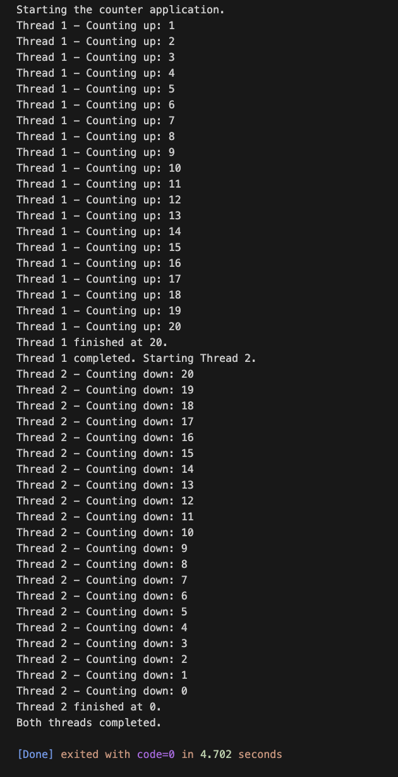

Concurrency Concepts
Concurrency creates the ability for a program to manage multiple tasks as they perform at the same time. While it has a tendency to improve responsiveness, it can also introduce certain security vulnerabilities into the program. This project shows a Java application as well as a C++ version, both of which are tasked to complete the same prompt. In both cases, the program contains two threads, one of which counts from 1 to 20 and the other counts backwards from 20 to 0 once the first thread fully completes. If we compare the overall designs and concepts of concurrency from each version of the program, we will see a large difference in which would be considered less vulnerable to security threats.
Looking at the Java application as a whole, it contains the two thread classes and the main method creates both objectives and controls when in which they execute themselves. It also contains exception handling for an interrupted exception that is used when a thread is interrupted while waiting, it is able to restore the status with Thread.currentThread().interrupt(). What happens after is the counting method returns rather than continuing as if there was no interruption at all. Overall, this improves responsiveness to any sort of interruption or cancellation that may occur while the program is running. This version uses threads as a way of showing controlled execution and coordination within the program. Both Java and C++ have the abilities to implement multithreaded applications. The difference is that they compile and manage runtime differently, which also influences the performance of the programs. C++ typically is compiled ahead of time which can eliminate unnecessary operations. The performance of this version also depends on the compiler itself. On the other hand, Java source code is typically compiled into bytecode. Due to this, it is able to be compiled more frequently.
As the implementation process of concurrency in Java continues, it is typical for performance issues to arise based on how the threads interact with the operating system and how they are able to manage shared memory. Another factor that affects performance would be synchronization. Using join() to establish a dependency between the threads, it also avoids synchronized counter operations. Although it works in this program, in a more complex application, there would be issues with failing to synchronize.
Strings were used in this application in order to give descriptive console messages. The messages are not accepted from an external user. The strings within a Java application are easier to share safely between threads since their contents are not able to be changed after the string object is created. This, unfortunately, does not exclude the application from a security issue involving the text. Through unsafe handling, or other examples, it is still possible to expose vulnerabilities. C++, on the other hand, manages its own character storage for their strings. Using these has the ability to reduce certain risks, but the memory and buffer management need to be correct.
This example of a counter application in Java, its integer is originally assigned 32 bits. Since the values used in this application are very much within the range, there is not a realistic risk for its security because of its data type. C++ needs more attention when it comes to the types of data they are using. Programmers need to select the correct type for their application and also validate their inputs.
In this example, the Java applications would be considered as less vulnerable to security threats because it uses managed memory and immutable strings. Although in other cases, with a carefully written C++ program using containers and strings it also has the possibility to be very secure if completed correctly. Performance and security both depend on the language and also the implementations. Since language alone does not ensure the security of a program, any language can be vulnerable to security threats and can also have a reduced chance if it is carefully written and executed.

